This page introduces the challenge, focusing on penetration testing for IoT (Internet of Things).
IoT refers to interconnected devices and the technologies that enable communication between them and the cloud.
The initial setup involves connecting to the TryHackMe VPN or using the attack box. Furthermore, I install RustScan as a faster alternative to Nmap for port scanning as you can see the picture below.

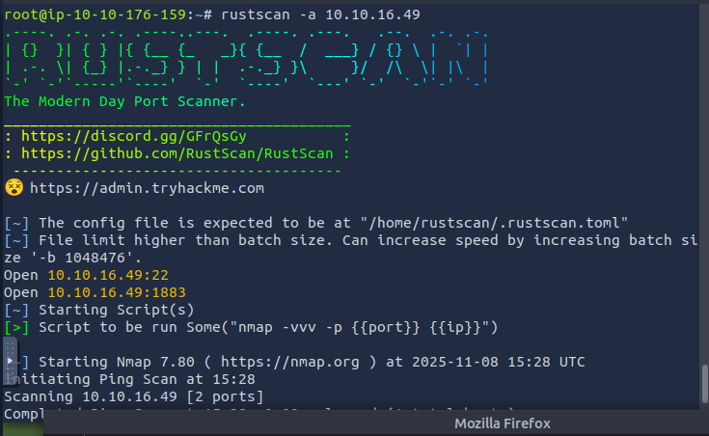

I use RustScan with the -a flag to specify the target IP address. The scan reveals an open port: 1883. An Nmap scan is then initiated to identify the services running on this port.
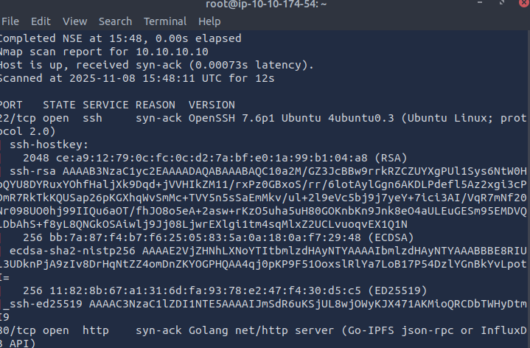

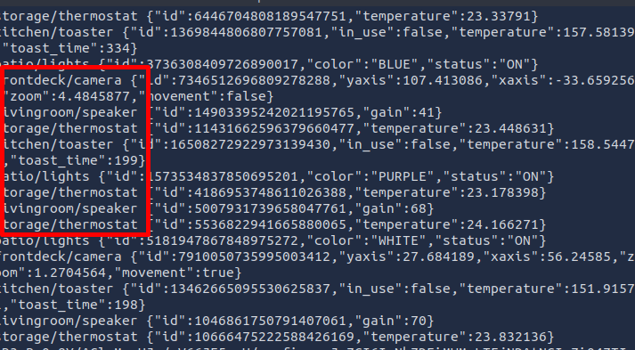
I installed Mosquitto on my machine using the command sudo apt-get install mosquitto mosquitto-clients.
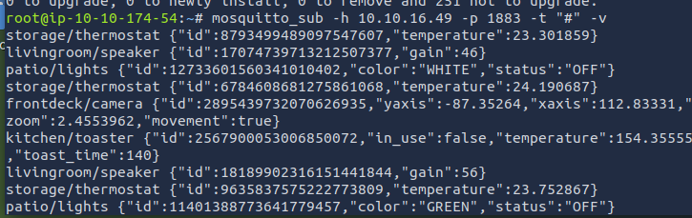

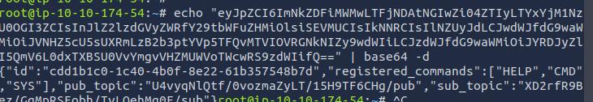
The result above displays our subscriber ID, registered commands, pub_topic, and sub_topic. This information will be crucial for enabling us to transmit requests in base64 and receive responses also in base64.
We must establish our subscriber to monitor answers and present them in base64 format for decoding. We accomplish this by executing the command $ mosquitto_sub -t "our pub_topic identified previously" -h target IP.
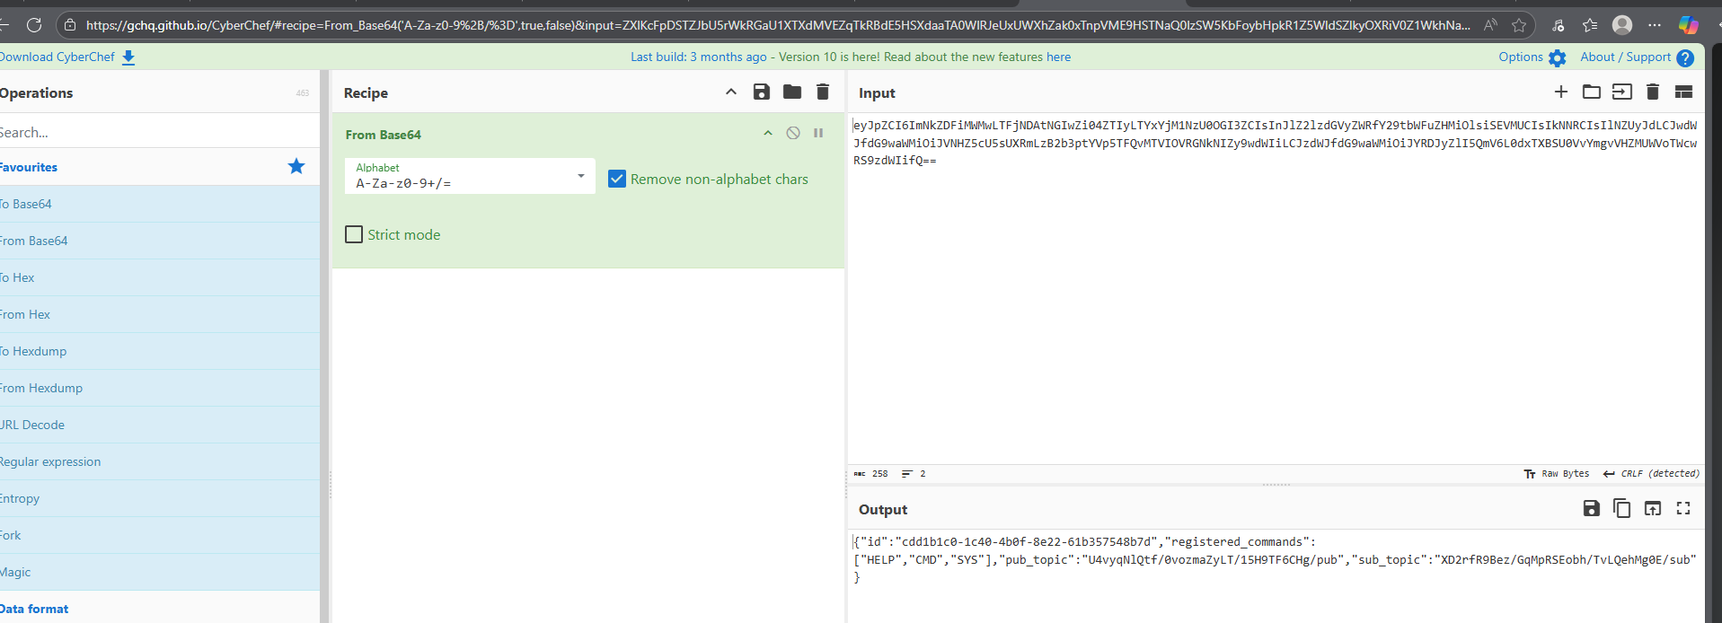

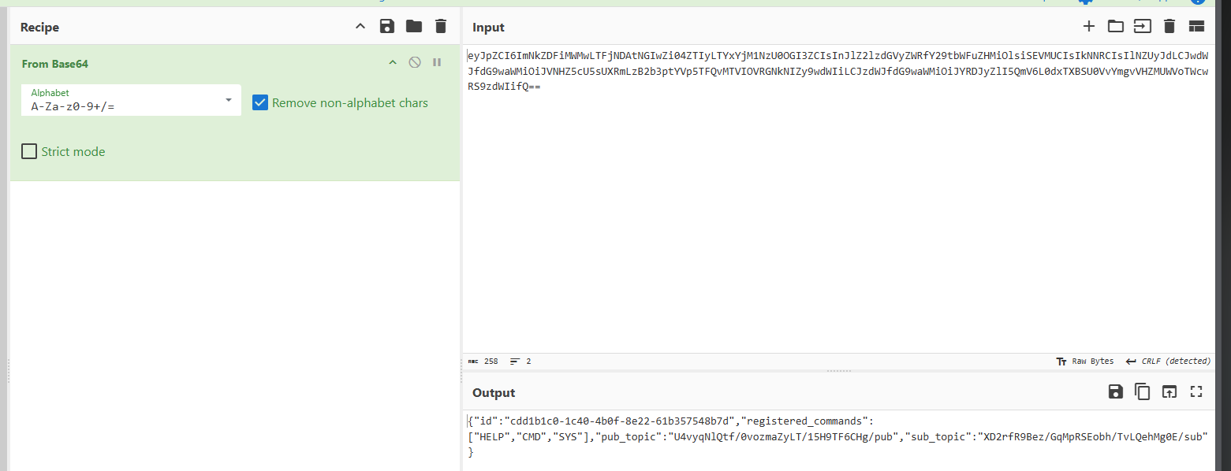

Subsequently, we will execute commands to solicit responses from our subscriber by leveraging our publisher. Our command will resemble the aforementioned subcommand; however, this time we will modify it to 'pub' and incorporate our message. The command will be $ mosquitto_pub -t "our sub_topic we discovered" -h targetIP -m "our message in base64"

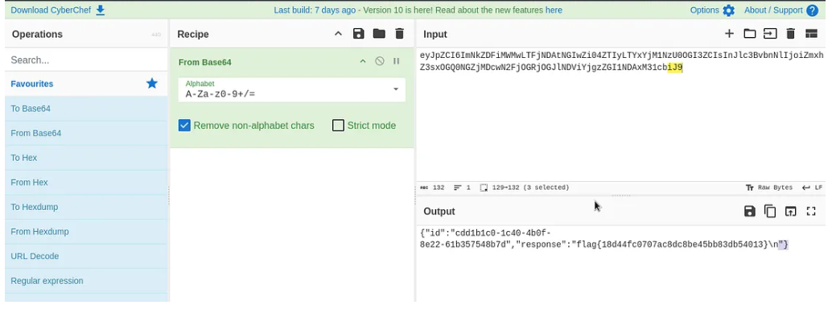

Our flag is revealed by deciphering the response as you can see in the above

gobuster dir -u http://10.10.231.67 -w /usr/share/wordlists/dirb/common.txt
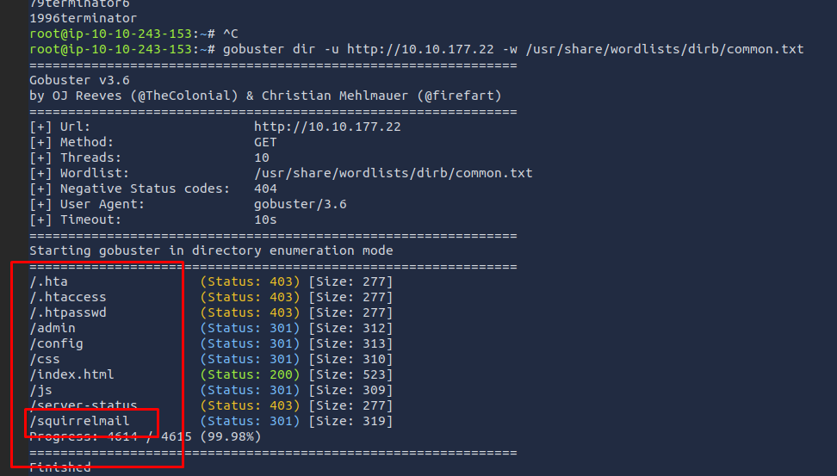
http://10.10.177.22/45kra24zxs28v3yd/administrator/
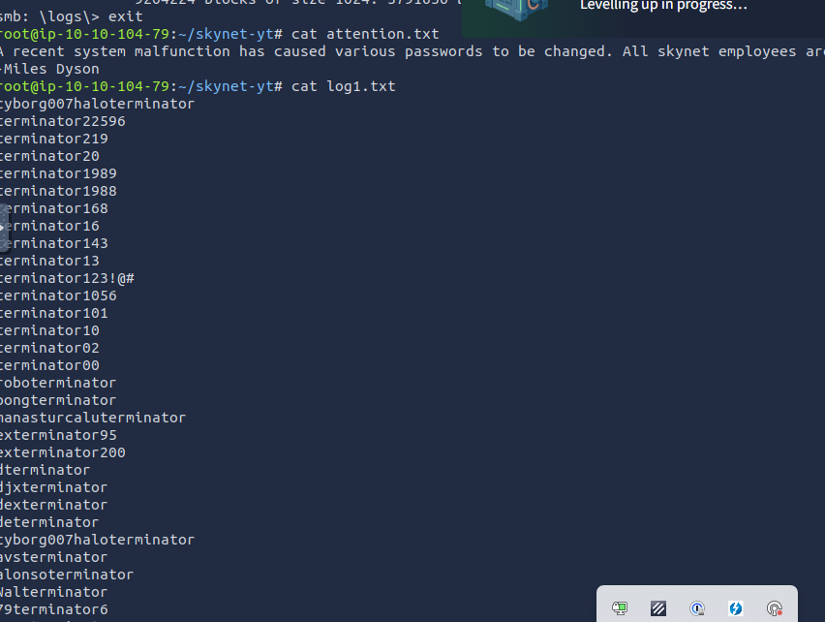

SquirrelMail 1.4.23 [SVN]

